Order Flow for Internalized Orders – From CMI

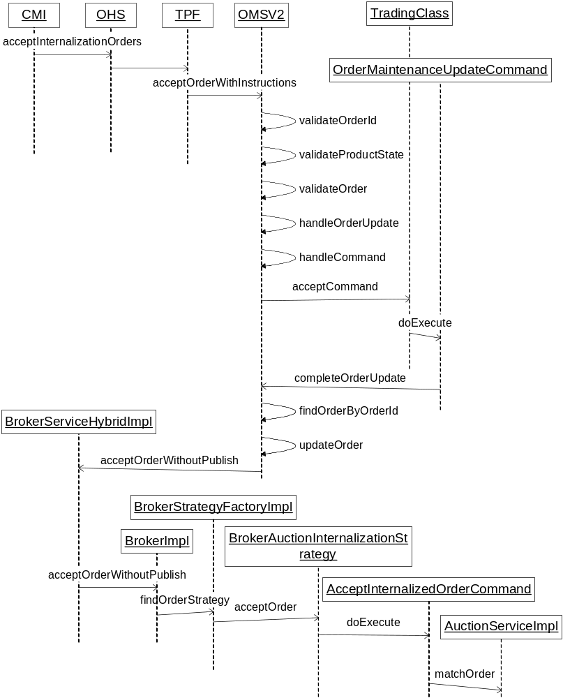

Order Flow for Internalized Orders – From COMPASS

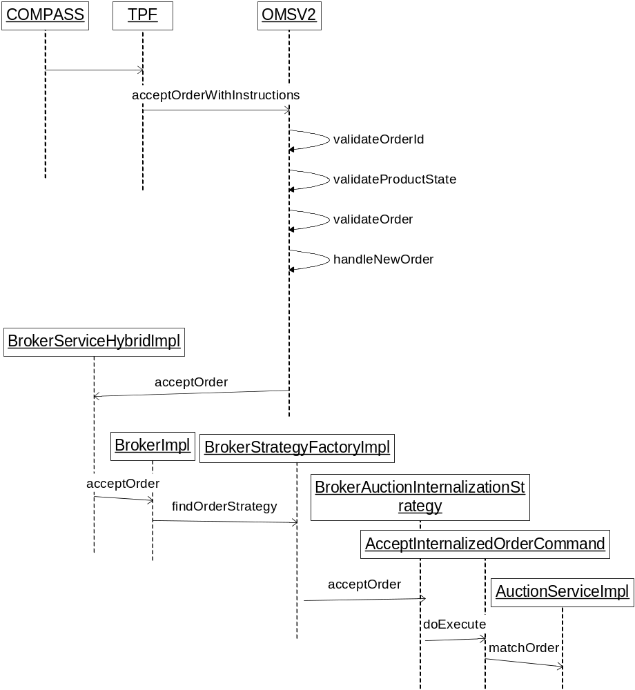

Order Flow for Internalized Orders – Match Order is found (Pair is not null)

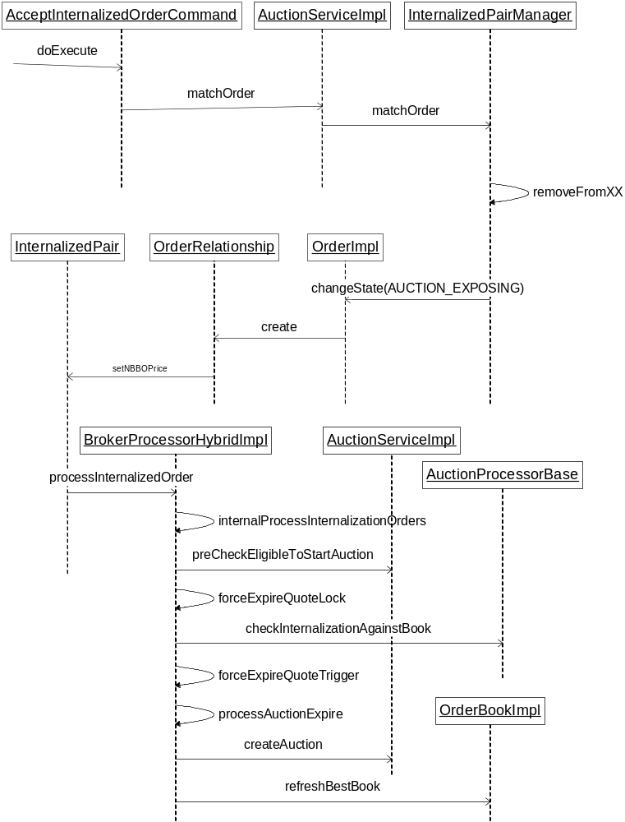

Order Flow for Internalized Orders – Incoming Firm Order does not find Internalized Order

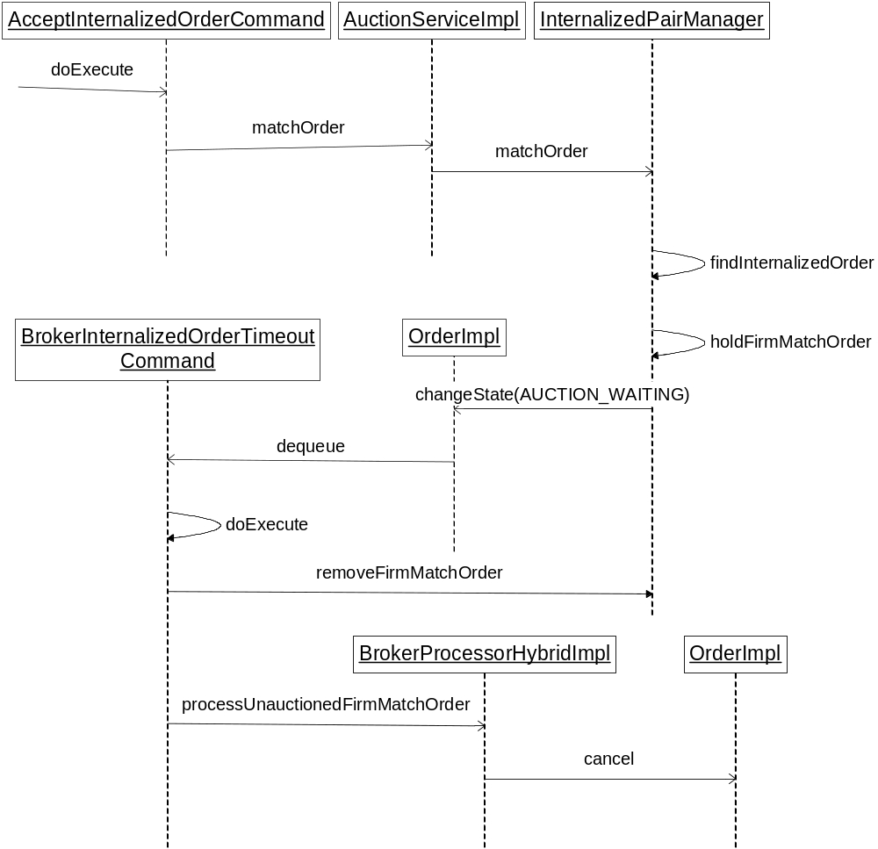

Order Flow for Internalized Orders – Incoming Internalized Order does not find Firm Order

